**Problem 6:**

INSERT INTO LOCATION (LOCNO, FACNO, LOCNAME)

VALUES (‘L107’,’F104’,’Door’);

**Snapshot for the Problem:**

1. **Before inserting**

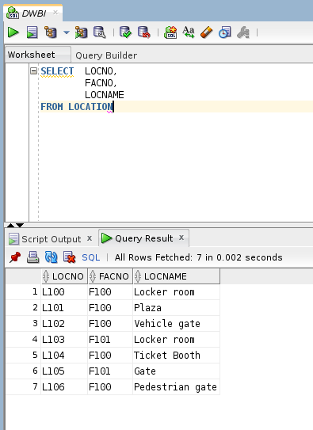

1. **Executing the insert query**

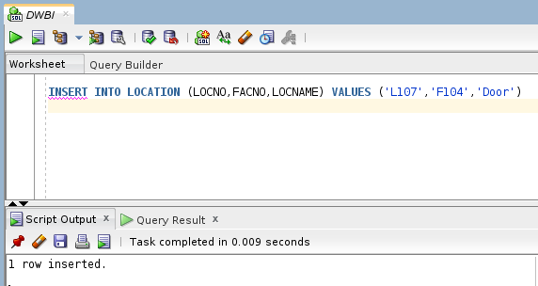

1. **After executing**